|  |
| --- |
|  |
| 新概念 3 册 |
| Lesson44 |

Lesson 44 Speed and comfort

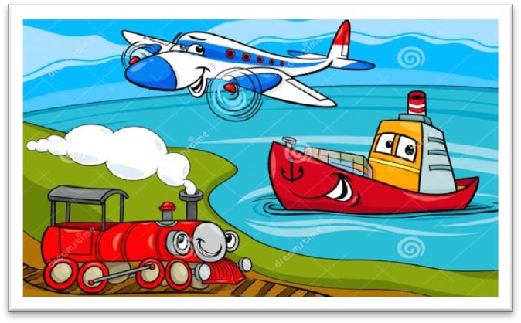

**monotonous [mə'nɒtənəs] adj. 无聊的，单调的**

Reading is only a partial solution, for the monotonous rhythm of the wheels clicking on the rails soon lulls you to sleep.

The same old favorites recur year in year out with monotonous regularity. The little boy wets the bed with monotonous regularity.

dull

This invariably wins them the love and respect of others, for they add colour to the dull routine of everyday life.

“mon(o)” = single monologue monogamy monoplane

a monolingual dictionary monarch / monarchy **click [klɪk]**

v. 发出喀哒声

click one’s fingers

The door clicked shut.

The soldier clicked his heels. He slammed / banged the door.

The door slammed / banged shut.

The dog shut the door.

The shout was heard through the door.

The door of the bank was locked.

The door closed loudly. The door banged shut.

Answer: (D) The door closed loudly.

When Mrs. Richards walked towards him, he fled, slamming the door behind him.

If fifty pence pieces are not exchanged for sweets, they rattle for months inside money boxes. As it was extremely heavy, he dumped it on the counter.

The order to abandon ship was given and hundreds of people plunged into the icy water. They plunged into the lake, …

We all clapped our hands.

Don’t clatter the dishes—you’ll wake the baby up.

I’ll smack your bottom if you don’t behave yourself.

inspection [ɪn'spekʃn]

**n. 检查**

“spect” = look

inspect / inspector / inspection expect / expectation

suspect / suspicion / suspicious spectacle / spectacular circumspect / circumspection prospect

The road is tortuous, but the prospects are bright. retrospect

In retrospect, I think my marriage was doomed from the beginning.

intimidate [ɪn'tɪmɪdeɪt]

**v. 恐吓，威胁**

timid adj. 胆小的

intimidate / intimidating / intimidation

Hatred is the coward's revenge for being intimidated.

— George Bernard Shaw

intimidate sb. into … cow sb. into ..

bully sb. into …

People travelling long distances frequently have to decide whether they would prefer to go by land, sea, or air.

hardly anyone = almost no one hardly anything = almost nothing hardly ever = almost never

Hardly anyone writes to me these days. Dad ate hardly anything.

Though he owned a large car, he hardly ever used it, preferring always to go on foot.

positively adv. used to emphasize the truth of a statement, esp. when this is surprising （加强语气）真，真的很，真的是

Some diets may be positively dangerous.

Tonight's performance is positively the last time the band will appear together.

造句：很少有人真喜欢几天以上吃同一种食物。

Hardly anyone can positively enjoy eating the same food for more than a few days.

..., for she had sixteen watertight compartments.

compartment

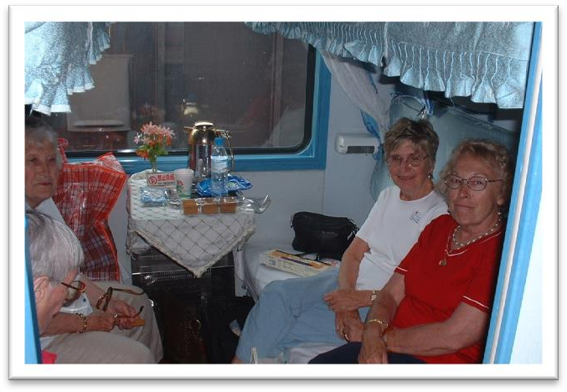

a cramped room / office / cabin

造句：走廊 (corridor) 如此狭小我只好侧着身子 (edge my way) 走过去。

The corridor was so cramped that I had to edge my way through it. spacious

You can stretch your legs on the spacious decks, ... stuffy

The room is too stuffy. Please open the window to allow the air to circulate. stuffed

take one’s mind off sth.

It is almost impossible to take my mind off my dog’s death.

The good thing about running is that it takes my mind off any problems I've got. She found that hard work was the best way to take her mind off her sorrow.

be haunted by …

I am haunted by homesickness.

After 30 years he is still haunted by the experience of fighting in Vietnam.

take ... off ...

She was so pretty — I couldn't take my eyes off her.

"Have you seen James without his beard?" "I know — it takes years off him!“

take time off

Do you still live there?

Oh yes, yes. My husband‘s there now. He couldn't take time off to come to New York with me. I have to take time off from work / school to go to the dentist.

take a day off

take the afternoon off

Reading is only a partial solution, for the monotonous rhythm of the wheels clicking on the rails soon lulls you to sleep.

partial

a partial solution / success

a partial solar / lunar eclipse a total solar / lunar eclipse

造句：吃药只能解决部分问题, 最重要的是你必须要过有规律的生活。

A truly dedicated bargain hunter must have patience, and above all, the ability to recognize the worth of something when he sees it.

Rastus leads an orderly life.

造句：吃药只能解决部分问题, 最重要的是你必须要过有规律的生活。

Taking medicine is only a partial solution, and above all, you have to lead an orderly life. rhythm 节奏

beat 节拍

melody 旋律

Let’s dance to the beat. lull sb. to sleep

lull a baby to sleep lullaby

造句：这梦幻般的音乐使我沉沉睡去。

The dream-like music lulls me to sleep. During the day, sleep comes in snatches. toss and turn

Both of us were exhausted.

We always tried to rest after exercising.

I turned over and went to sleep again.

I was overtired and couldn't sleep.

Last night I tossed and turned in bed, too exhausted to sleep. Answer: (D) I was overtired and couldn't sleep.

If you are lucky enough to get a sleeper, you spend half the night staring at the small blue light in the ceiling, or fumbling to find your ticket for inspection.

sleeper n. 1. 卧铺车；卧铺车厢；卧铺床位

sleeper n. 2. 睡觉的人

a light / heavy sleeper

大 形 年 新 颜 国 材 用+中心名词

a little white lamb small black boxes

As we were walking past a shop, he held a diamond firmly against the window and made a deep impression in the glass.

He hit me on the nose.

He hit me in the face.

inevitably adv. 必然，不可避免

Inevitably the repair job was not quite so simple. inevitable adj. 必然的，不可避免的

Those who make peaceful revolution impossible will make violent revolution inevitable.

— John F. Kennedy

sth. can’t be helped

She can't help the man look for another platter.

She forgot the platter had been broken.

She didn't realize the platter had been broken.

She doesn't want the man to replace the platter.

M: I don’t know how I managed to break that platter. I’ll be more than happy to buy you a new one.

W: Forget about it. Some things just can’t be helped. What does the woman mean?

Answer: (D) She doesn't want the man to replace the platter.

…, you will arrive at your destination fresh and uncrumpled. When I got home, I was tired and sleepy.

I got home tired and sleepy.

…, for you are quite impossible to read. X

On motorways you can, *at least*, travel fairly safely at high speeds, but *more often than not*, the greater part of the journey is spent on roads with few service stations and too much traffic. motorway expressway freeway

more often than not as often as not

More often than not, the arguments could have been avoided. all too often

All too often, parents leave their children home alone. every so often

She still calls me every so often. sometimes occasionally once in a while

from time to time (every) now and then (every) now and again

petrol / service station gas station Meanwhile, the traffic piled up behind.

造句：我的几个住在乡下的熟人每年进城一两次来看戏，对他们来说这是一种特殊的享受了， 但是通常旅程中大部分时间花在了路上，在路上加油站很少，车辆却很多。

Some of my acquaintances in the country come up to town once or twice a year to visit the theatre as a special treat.

Some of my acquaintances in the country come up to town once or twice a year to visit the theatre as a special treat, but more often than not, the greater part of the journey is spent on roads with few service stations and too much traffic.

by / in comparison pale in / by comparison

I thought I was badly treated but my experiences pale in comparison with yours. by / in contrast

A run-down watch is still a watch and can be rewound. An old watch, by contrast, becomes so worn and unreliable that it eventually is not worth mending.

In his own lifetime Galileo was the centre of violent controversy; but the scientific dust has long since settled, and today we can see even his famous clash with the Inquisition in something like its proper perspective. But, in contrast, it is only in modern times that Galileo has become a

problem child for historians of science. compared with / to ...

in / by comparison with / to ... in / by contrast with / to ...

It's as if they were, in some sense, cosmic beings in violent and lovely contrast with us suburban creatures.

A as against B is as C against D

The military power of the US, as against that of DPRK, is as the strength of an elephant against that of a mouse.

comforts n. 使人感觉舒适的事物

hotels with all the modern comforts

After the trip, it was nice getting back to a few home comforts. stretch one’s legs

take a walk / stroll have a walk / stroll go for a walk / stroll

He usually takes a short walk in the evenings and is always home by seven o'clock.

The idea never appealed to me very much, but one day, after heavy shower, I happened to be walking in my garden when I noticed a huge number of snails taking a stroll on some of my prize plants.

What do you want to do after breakfast? Why don't we take a walk down to the river?

Phoebe: Hey, is Chandler here? Joey: No, no he went for a walk.

One wants to meet like-minded collectors, … assuming (that) … 以为；假定，假如

Assuming that his family had been killed during an air raid, Hans settled down in a village fifty miles away where he had remained ever since.

造句：你将用半小时到那里——当然假定路上车不多的话。

You’ll get there in half an hour —assuming, of course, that the traffic is not heavy.

If it is not (calm), and you are likely to get seasick, no form of transport could be worse. transport / transportation

public transport / transportation

A lot of people object to mobile phones, especially when they are used in public places like restaurants or on public transport.

否定词+比较级=最高级

Nothing could have been more annoying.

No creature has received more praise and abuse than the common garden snail.

There is no quicker method of disposing of patients than by giving them what they are asking for. Nothing can be compared, he maintains, with the first cockcrow, the twittering of birds at dawn, the sight of the rising sun glinting on the trees and pastures.

But nothing can match them for speed and comfort. Nobody equals / matches him in strength.

In English she has no equal in her class.

In computer programming, Susan is head and shoulders above the rest of us. relatively few / easy / new / minor …

Cave exploration, or pot-holing, as it has come to be known, is a relatively new sport. be prepared to do = be willing / ready to do

Why people are prepared to tolerate a four-hour journey each day for the dubious privilege of living in the country is beyond me.

sacrifice … for …

Such is human nature, that a great many people are often willing to sacrifice higher pay for the privilege of becoming white-collar workers.

造句：没有多少人愿意为了钱而牺牲掉自己作为人的尊严。

Relatively few people are prepared to sacrifice their human dignity for money. have the reputation of being …

She has the reputation of being a good doctor.

Peter has the reputation of being the worst boy in the class.

hardened adj. someone who is hardened has had a lot of difficult or unpleasant experiences and is no longer much affected by such things 老练的，老资格的，见怪不怪的，麻木不仁的

The hardened professional smuggler, on the other hand, is never troubled by such feelings, even if he has five hundred gold watches hidden in his suitcase.

have the disadvantage of …

He has the disadvantage of being unable to drive a car. have the advantage of …

Though she has the twin advantages of wealth and beauty, she doesn’t live a happy life. Travelling *at a height of 30,000 feet, far above the clouds, and at over 500 miles an hour* is an exhilarating experience.

exhilarating adj. 令人极其兴奋和高兴的

There is nothing more exhilarating than to be shot at without result.

— Sir Winston Churchill

They devise hundreds of competitions which will enable us to win huge sums of money. settle v. 舒适地坐到……

settle back in a deep armchair

We settled in front of the television for the evening.

Jessica settled herself on the sofa with a small sigh of relief.

Six hundred years ago, Sir John Hawkwood arrived in Italy with a band of soldiers and settled near Florence.

Assuming that his family had been killed during an air raid, Hans settled down in a village fifty miles away where he had remained ever since.

He had often dreamed of retiring in England and had planned to settle down in the country. The two men quarrelled bitterly and it was clear that the argument could only be settled by a fight.

escapist n. 遁世逍遥者，逃避现实生活一心享受的人

**service** n. BrE a regular journey made by a bus, train, boat, plane etc to a particular place at a particular time **汽车，火车，轮船，飞机等的班次**

the 8:15 service to Cambridge refinement

With several refinements your essay would be excellent.

occupy vt. 占据（时间，空间等）

A little later, a man came along with a biscuit which occupied the whole boot of his car. Mainframe computers were very large indeed, often occupying whole air-conditioned rooms, employing full-time technicians and run on specially-written software.

occupied adj. 忙的，有事做的

keep sb. occupied

We need something to keep the children occupied. The West Lake is breathtakingly beautiful!

take a … breath

He took a deep breath to compose himself.

If the landscape is hidden from view, you can enjoy the extraordinary sight of unbroken cloud plains that stretch out for miles before you, *while the sun shines brilliantly in a clear sky*. landscape n. 1. scenery of an area of land （陆上的）风景, 景色

landscape n. 2. picture showing a view of the countryside 野外风景画

prevent sb. from doing

造句：在新社会, 每个孩子都能接受良好的教育。

In the new society, there is nothing to prevent a child from receiving good education.

造句：她既有天赋又这么勤奋, 一定能实现自己的梦想。

Despite its immensity, it is both simple and elegant, fulfilling its designer's dream to create 'an enormous object drawn as faintly as possible'.

造句：她既有天赋又这么勤奋, 一定能实现自己的梦想。

She is so talented and diligent that there is nothing to prevent her from fulfilling her dream. However you decide to spend your time, one thing is certain: *you will arrive at your destination fresh and uncrumpled*.

造句：无论在前进的道路上 (on our road ahead) 遇到 (encounter) 什么样的困难, 有一件事是肯定的: 只要 (so long as) 我们坚持 (persist) 就一定能克服它 (manage to overcome it)。Whatever difficulty we may encounter on our road ahead, one thing is certain: *we will manage to overcome it so long as we persist*.

recover from … 从……中恢复

recover sth. 恢复了……

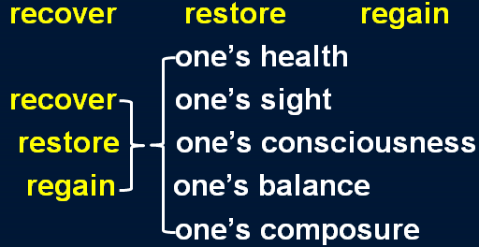

recover sth. 重新获得，找回，赚回，补偿

But the claim made by a local authority to recover the cost of salvaging a sunken pie dish must surely be unique.

arduous adj. 艰苦的, 费力的

Justice is part of the complex machinery of the law. Those who seek it undertake an arduous journey and can never be sure that they will find it.